IS-PHYS Lab

Title of the Report

Student’s name:
Partner’s name(s):
TA’s name:

Date that the lab was performed

Abstract
The purpose of an abstract in a scientific paper is to help a reader decide if your paper is of interest to him/her. The abstract should be able to stand by itself, and it should be brief. The abstract should contain 250 words or fewer. Generally, it consists of three parts which answer these questions:
• What did you do? – A statement of the purpose of the experiment, a concise description of the experiment and physics principles investigated.
• What were your results? – Highlight the most significant results of the experiment.
• What do these results tell you? – Depending on the type of experiment, this is conclusions and implications of the results or it may be lessons learned from the experiment.
Write the abstract after all the other sections are completed. (You need to know everything in the report before you can write a summary of it.)

Background
(Answers to each question 1~2 paragraph, can be short, but should use your own words. Length guideline: better not exceed two A4 pages)
Why conduct this experiment?
What is the physics behind?
How are you going to do it?
(you should include a sketch of the experimental setup with necessary definitions, such as …)
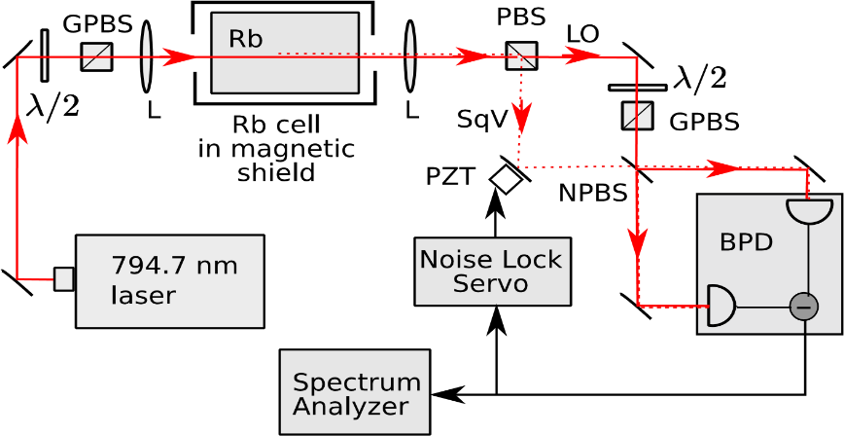
Figure 1 Every figure MUST have a caption.

Data
Include a photocopy of your original (raw) data behind your report. Your original (raw) data also needs to be included in this report section in tabular form. There should be a paragraph describing the data that is contained in the various tables. Your tables should either have a heading or a very clear figure caption. The information should be laid out in such a manner that it is obvious what you are trying to achieve.

Results and Discussion
This section contains the analysis of your experimental data. This analysis should include graphs and charts that display the data and the results of any calculations.
Calculations: In this section show any equations that you will be using along with a sample calculation for each.
Show equation Substitute values Calculate answer
It is not necessary to show the details of every calculation that you perform, one sample of each formula is sufficient.
Graphing: Graphs should be done on graph paper or printed from an application such as Excel. They should not be done on plain or quadrille paper. Every graph should have a title and the axes should be properly labeled with the correct units.
Table 1: Every table MUST have a caption.
x (m) | V (V)
0.0044151 | 0.0030871
0.0021633 | 0.0021343
0.0003600 | 0.0018642
0.0023831 | 0.0013287

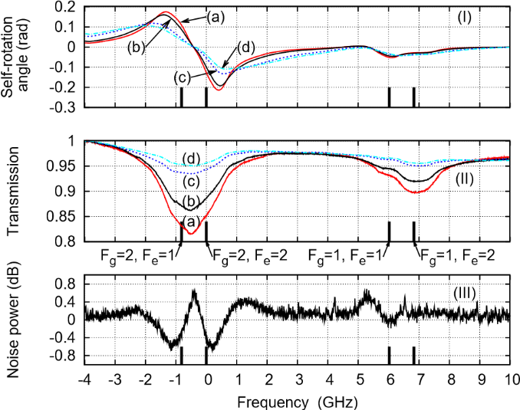
Figure 2 Every plot MUST have axes labeled.
4 Conclusions
This is the summary section where you need to demonstrate that you understand the experiment that you just completed. Include a one-paragraph summary explaining very clearly your principal results

